**Team PJT – Outline (Team HAPPY)**

1. **Project Title**

* **What Factors Have Higher Correlation to the Level of Happiness?**

1. **Team Members**

* **Paul Dean, Soobin Hwang, Mark Gatongay, Seunghwa Jun**

1. **Project Outline**

* **Given ‘The World Happiness Report 2019’ and country rankings,**

**This project tries to find** **what factors relate more to the level of happiness.**

* **First, it delves into the given of the country happiness rankings, analyzes them, and visualizes the results.**
* ‘The World Happiness Report’ ranks 156 countries based entirely on the survey,

and provides the ranks of 6 factors to help explain life evaluations: GDP, Social Supporting, Life Expectancy, Freedom, Generosity, and Corruption Level.

* The project analyzes the datasets from 2015 to 2019, and visualizes the results with the geographical heatmap, ranking change line graph, etc.

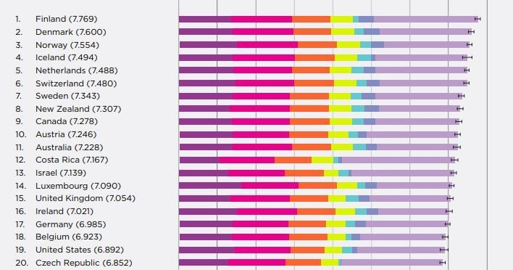

* **Second, it expands the horizon and tries to find more factors and related datasets that correlate the level of happiness of a country, analyzes them, and visualizes the results.**
* Possible datasets include: Obesity, Unemployment Rate, Birth Rate, Population Density
* Scatter plots and geographical heatmap layers for each factors will be drawn.

1. **Research Questions to Answer**

**[ Part I – What are the Happy or Miserable Countries? ]**

* Which region and counties are the happiest? (2019)
* Geographical Heatmap
* What are the yearly changes of the rankings by region ? (2015-2019)
* Line Graph

**[ Part II – What Factors Correlate More to the Level of Happiness? ]**

* What are the top two highly correlated factors among 10 indices:

1) GDP, 2) Social Supporting, 3) Life Expectancy, 4) Freedom,

5) Generosity, 6)Corruption Level, 7) Obesity, 8) Unemployment,

9) Birth Rate, 10) Population Density

* Scatter Plot of each factor
* Coefficients Line for each plot
* Bar Graph of the correlation ranks
* What are the correlations of 10 factors for each country’s happiness level?
* Input Query
* Bar Graph

**[ Part III – Why and How the Top Two Factors Are Correlated to Level of Happiness ]**

* Try to explain the results, conclusions, limitations

1. **Datasets to Be Used**

* The World Happiness Report 2019, 2018, 2017, 2016, 2015 (csv files)
* CIA, World Banks datasets
* Gmaps API

1. **Rough Breakdown of Tasks – By Research Question**

* Collect, merge, and clean all the required data.
* Analyze the data and visualization